# CS 6043 Computer Networking

# PROJECT 4

By Mitra Sasanka Darbha, M#13523468

# Part 1: Ethernet, ARP

## 1.1

Destination address is 00:06:25:da:af:73. This is not the Ethernet address of gaia.cs.umass.edu. This is the Ethernet address of Linksys router (Gateway to Internet).

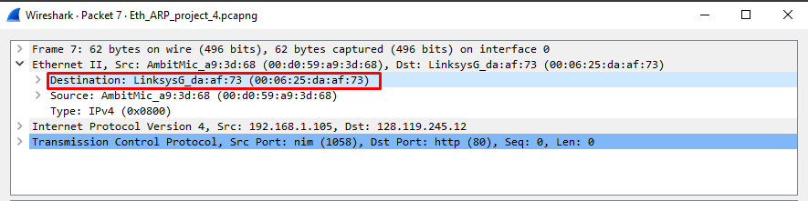

## 1.2

Hexadecimal value = 0x0800. This corresponds to IPv4 protocol

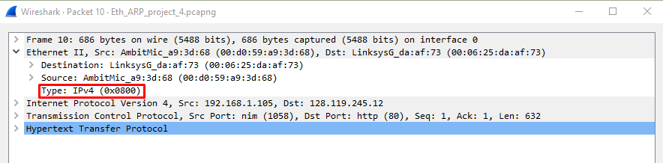

## 1.3

Source address – 00:d0:59:a9:3d:68

Destination address – ff:ff:ff:ff:ff:ff

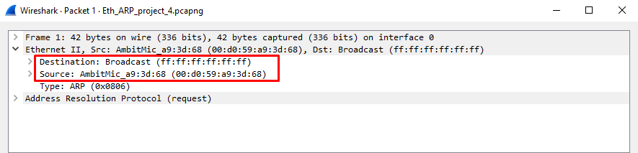

## 1.4

Yes. The host requesting ARP is 192.168.1.105

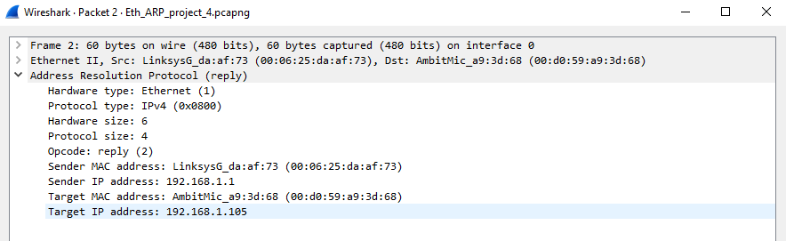

# Part 2: 802.11

## 2.1

They are “Linksys12” and “30 Munroe St.”

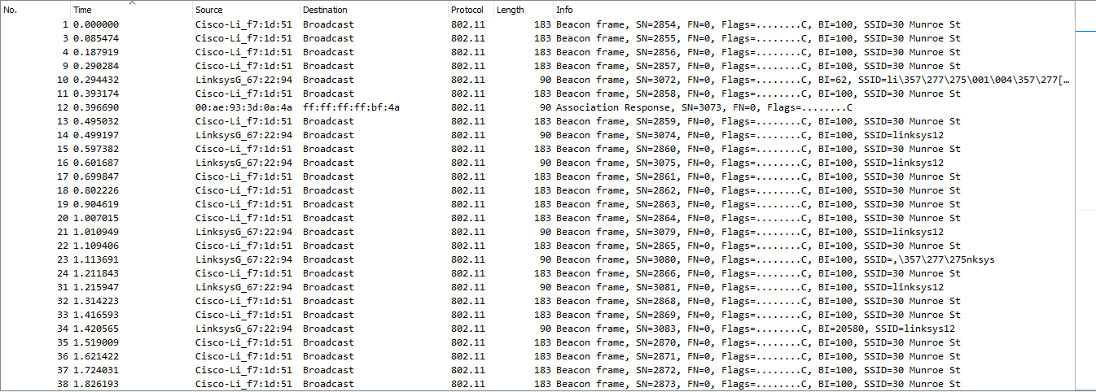

## 2.2

Time interval between Beacon frames of “*30 Monroe St.”* access point is 0.1024 secs. This value can be obtained by the difference of any two consecutive beacon frames sent from this access point.

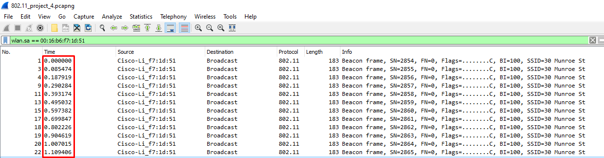

## 2.3

The support rates are 1.0, 2.0, 5.5, 11.0 Mbps. The extended rates are 6.0, 9.0, 12.0, 18.0, 24.0, 36.0, 48.0 and 54.0 Mbps.

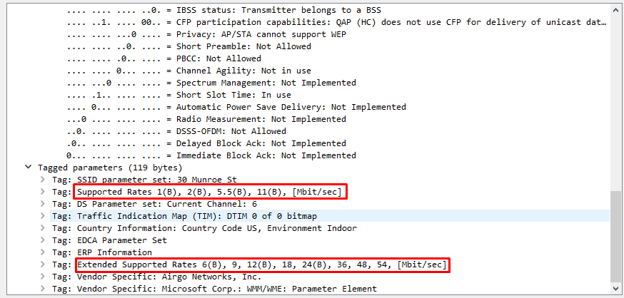

## 2.4

The three MAC addresses are: BSS Id, source address and destination address.

Cisco-Li_f7:1d:51 (00:16:b6:f7:1d:51)

IntelCor_d1:b6:4f (00:13:02:d1:b6:4f)

Cisco-Li_f4:eb:a8 (00:16:b6:f4:eb:a8)

Address corresponding to wireless host: IntelCor_d1:b6:4f (00:13:02:d1:b6:4f)

Address corresponding to first-hop router: Cisco-Li_f7:1d:51 (00:16:b6:f7:1d:51)

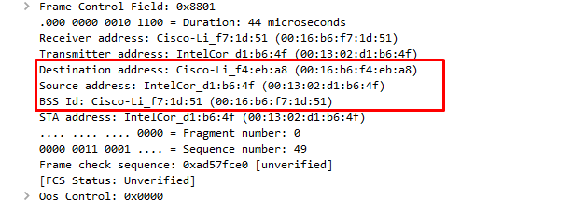

## 2.5

The two actions taken are “DHCP Release” and “Deauthentication” as seen in frames 1733 and 1735 respectively.

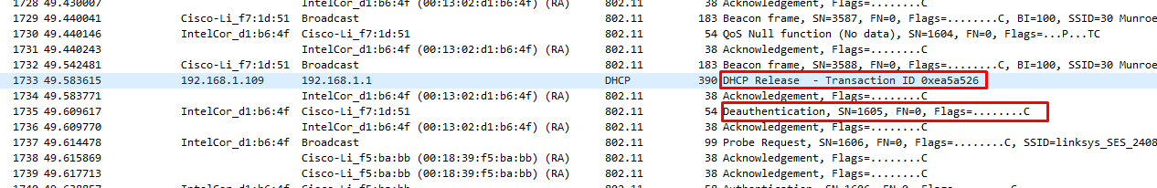

## 2.6

There are 15 AUTHENTICATION frames sent from the wireless host to linksys_ses_24086 (MAC address = Cisco_Li_f5:ba:bb)

